**SRM INSTITUTE OF SCIENCE AND TECHNOLOGY**



**DBMS PROJECT-1**

##### RAILWAY RESERVATION SYSTEM

**SUBMITTED TO**

Dr. Jeba Sonia

**Date:24/06/2022**

**Project Team:**

KOLLI GOPINADH (RA2011042010121) Sushank Sreeram (RA2011042010066)

Bobbiti Harshavardhan Reddy (RA2011042010043)

Medapati vivek aasish krishna reddy (RA2011042010052)

Abstract

The Railway Reservation System facilitates the passengers to enquire about the trains available on the basis of source and destination, Booking and Cancellation of tickets, enquire about the status of the booked ticket, etc. The aim of case study is to design and develop a database maintaining the records of different trains, train status, and passengers.

This project contains Introduction to the Railways reservation system .It is the computerized system of reserving the seats of train seats in advanced. It is mainly used for long route. On-line reservation has made the process for the reservation of seats very much easier than ever before.

In our country India, there are number of counters for the reservation of the seats and one can easily make reservations and get tickets. Then this project contains entity relationship model diagram based on railway reservation system and introduction to relation model .There is also design of the database of the railway reservation system based on relation model. Examples of some SQL queries to retrieve data from rail management database.

Introduction

Database is an organized collection of data. The data is typically organized to model aspects of reality in a way that supports processes requiring information. A DBMS makes it possible for end users to create, read, update and delete data in a database. The DBMS essentially serves as an interface between the database and end users or application programs, ensuring that data is consistently organized and remains easily accessible. The DBMS manages three important things: the data, the database engine that allows data to be accessed locked and modified and the database schema, which defines the database's logical structure. These three foundational elements help provide concurrency, security, data integrity and uniform administration procedures. The DBMS can offer both logical and physical data independence. That means it can protect users and applications from needing to know where data is stored or having to be concerned about changes to the physical structure of data.

The main purpose of maintaining database for Railway Reservation System is to reduce the manual errors involved in the booking and cancelling of tickets and make it convenient for the customers and providers to maintain the data about their customers and also about the seats availablet them. Due to automation many ailable loopholes that exist in the manual maintenance the records can be removed. The speed of obtaining and processing the data will be fast. For future expansion the proposed system can be web enabled so that clients can make various enquiries about trains between stations. Due to this, sometimes a lot of problems occur and they are facing many disputes with customers. To solve the above problem, we design a data base which includes customer details, availability of seats in trains. no of trains and their details.

## Proposed work details

The proposed work consists of 6 main tables that are interconnected. The team members work on tables and keep updating them by implementing queries.

The structure and function of each table are described below:

### Feature-Members

It has information about members of the whole reservation system. Details consist of Name of the member, ID, Password, E-mail and Number. ID here is the Primary key of the table.

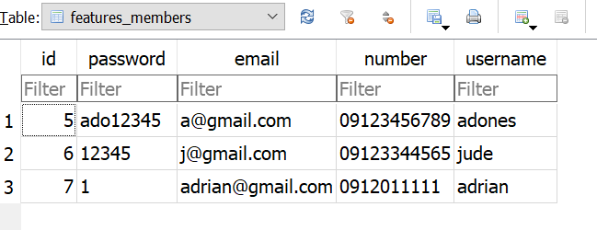

### Reservation

It has information about the customers who has reserved for the train. Details consist of ID, user name, number of persons, date of journey, amount paid, class of train, status, pnr number, train_ID, destination and source of customer.

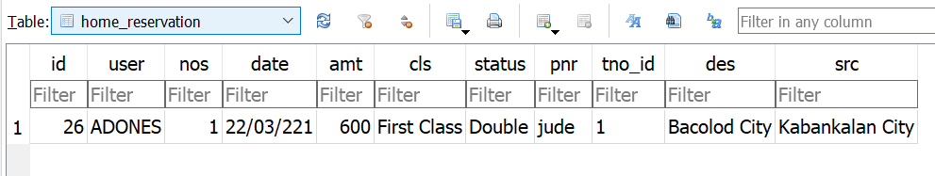

### Route

It has information about the route of a train. Details consist of ID, Route_ID, origin station and destination station.

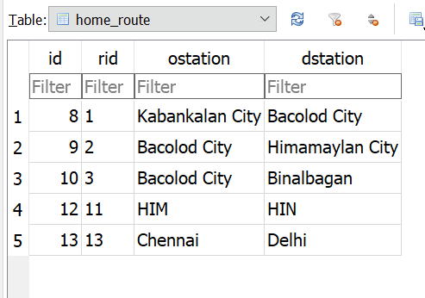

### Route-Station

It has information about arrival on station. Details consists of ID, Route_ID, S_ID, Train_ID, arrival time and order.

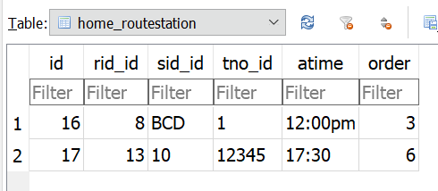

### Station

It has information about the Name of all stations. Details consist of station_ID and station name.

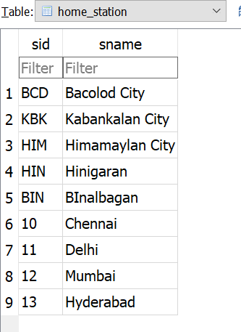

### Trains

It has information about train names. Details consist of Train name, route id and train number.

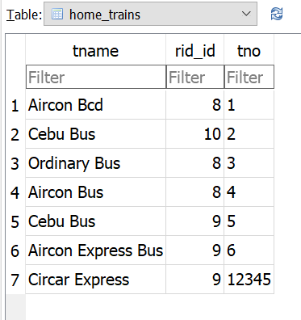

# ER-Diagram

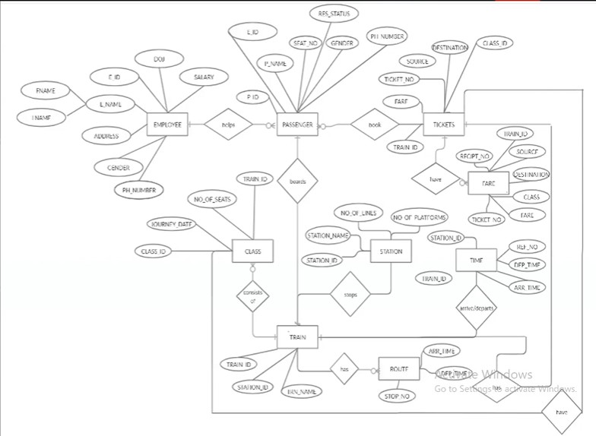

MINI PROJECT

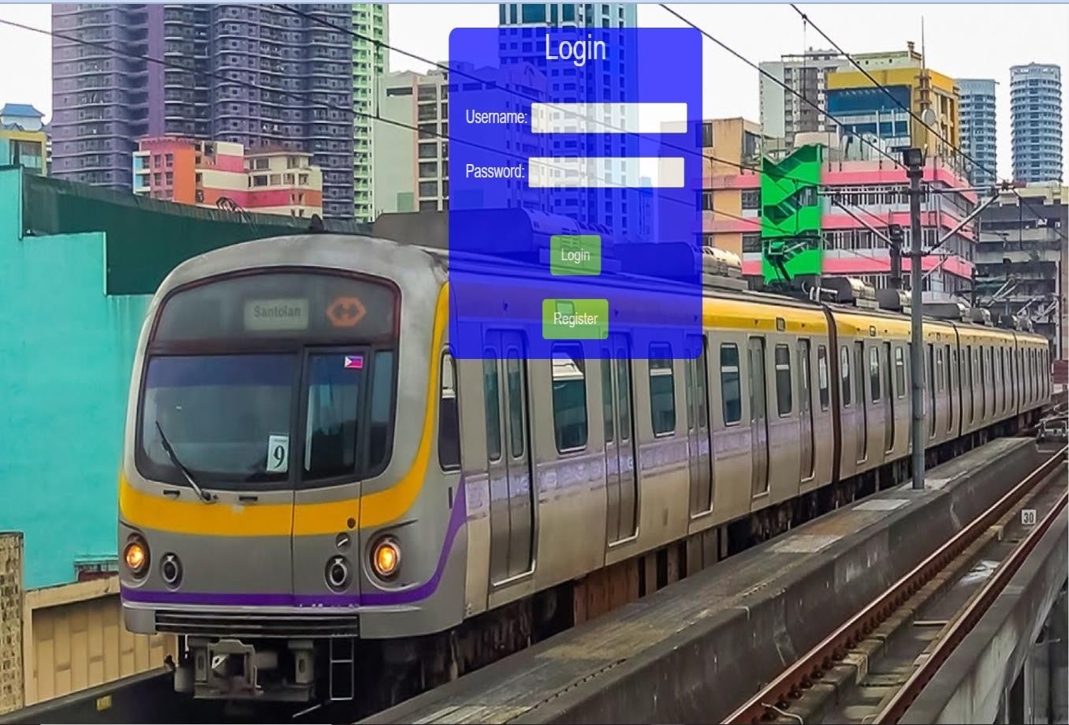

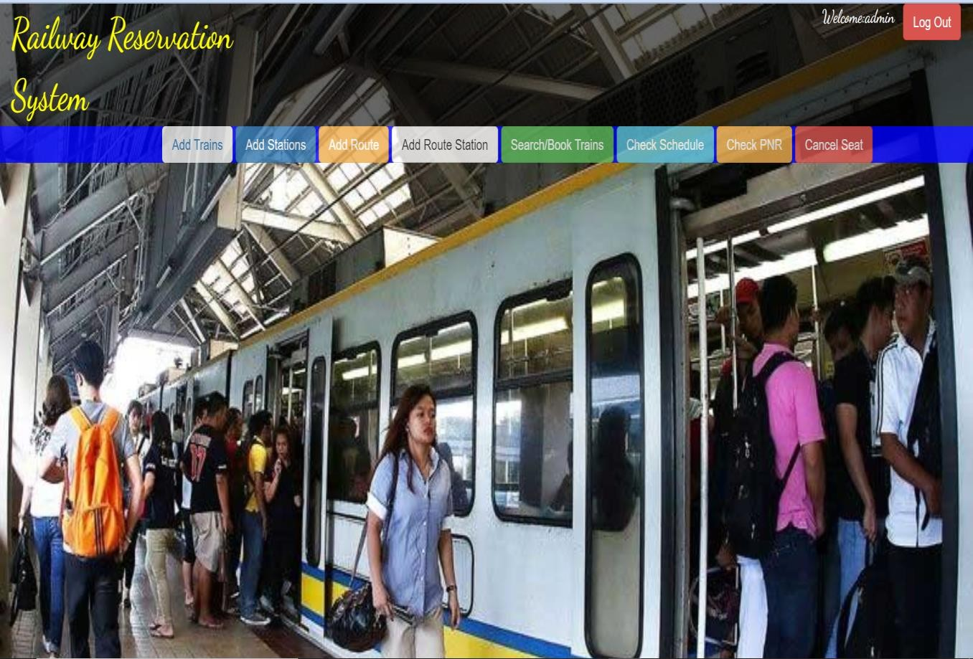

# Important Specification

ADD TRAIN

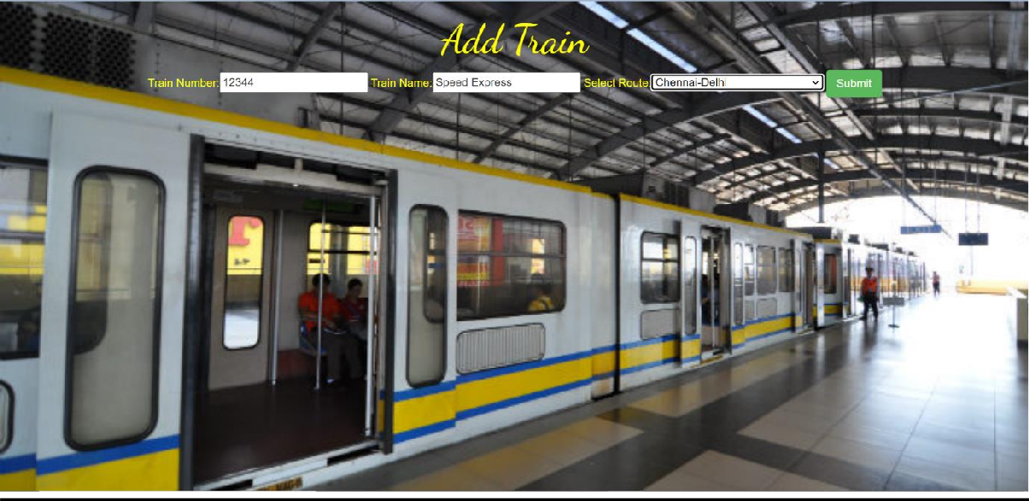

ADD STATION

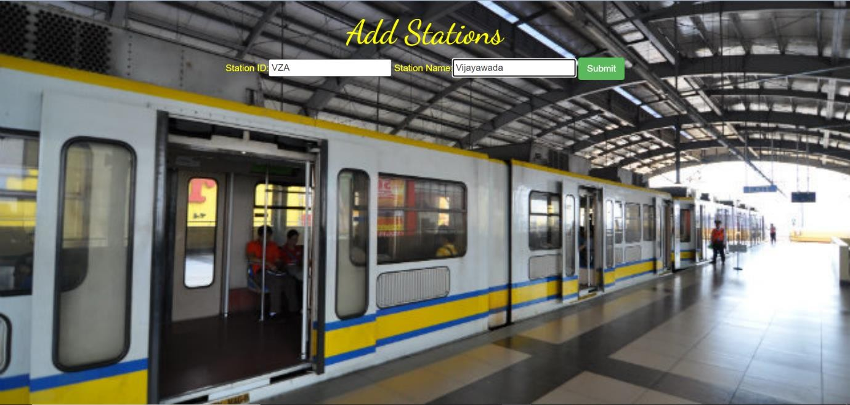

ADD ROUTES

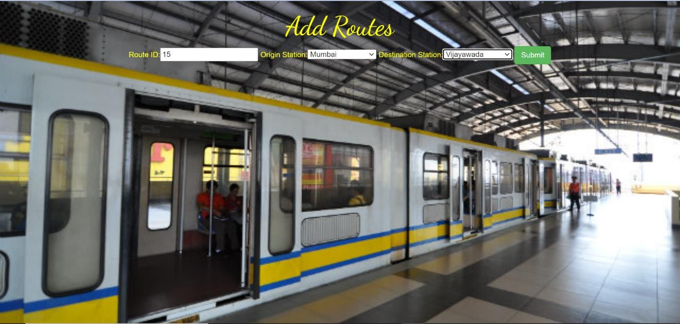

ADD ROUTE STATION

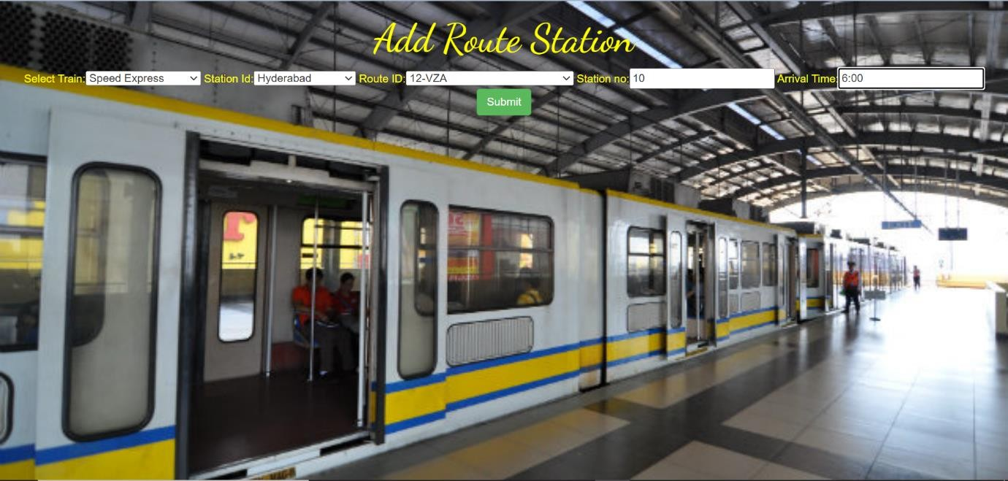

## TABLE SCREENSHOTS

##### WEEK -01 DDL COMMANDS

In the context of SQL, data definition or data description language (DDL) is a syntax for creating and modifying database objects such as tables, indices, and users.

* CREATE to create a new table or database.
* ALTER for alteration.
* Truncate to delete data from the table.
* DROP to drop a table.
* RENAME to rename a table.

##### TABLE-01

CREATE TABLE userdetails ( users_id int,

users_name varchar(50), address varchar(50),

age int,

contact_no number(10)

);

INSERT INTO userdetails VALUES (1001,'adam','first_cross street',20,9082736541);

INSERT INTO userdetails VALUES (1002,'lily','second_cross street',22,9037846251);

INSERT INTO userdetails VALUES (1003,'edi','third_cross street',19,9836728910);

INSERT INTO userdetails VALUES (1004,'pinky','brew street',27,8903567227);

INSERT INTO userdetails VALUES (1005,'kil','pent street',30,8946736829);

select * from userdetails;

desc userdetails;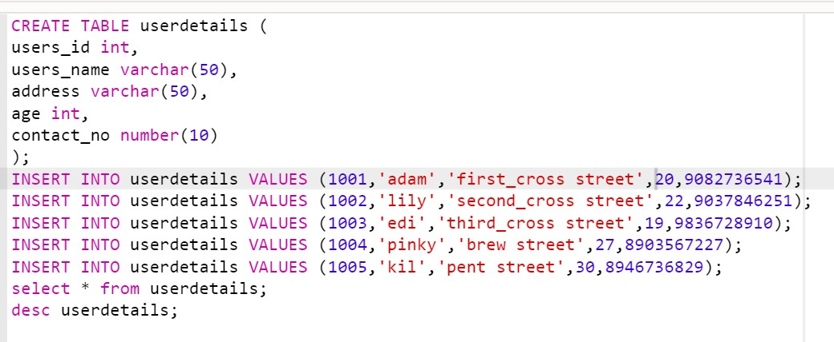

CREATE TABLE travel_agency_details ( agency_name varchar(50), name_of_the_passenger varchar(50), phone_no number(10),

address varchar(50)

);

INSERT INTO travel_agency_details VALUES ('pvr_agency','mr_ji',9864783920,'fouright_street');

INSERT INTO travel_agency_details VALUES ('meta- agency','mr_vick',9256378916,'pinky_sstreet');

INSERT INTO travel_agency_details VALUES('jihu_agency','john_richard',689972867',abc rohi street');

INSERT INTO travel_agency_details VALUES('rejoyce_agency','rimder singh',9048836676,'juhu beach road');

INSERT INTO travel_agency_details VALUES('rmg_junction','yusaf',9038768290,'jainson highway');

select * from travel_agency_details; desc travel_agency_details;

##### WEEK-02 DML COMMANDS

A data manipulation language (DML) is a computer programming language used for adding (inserting), deleting, and modifying (updating) data in a database.

* INSERT – is used to insert data into a table.
* UPDATE – is used to update existing data within a table.
* DELETE – is used to delete records from a database table.

INSERT INTO travel_agency_details VALUES ('pvr_agency','mr_ji',9864783920,'fouright_street');

INSERT INTO travel_agency_details VALUES ('meta- agency','mr_vick',9256378916,'pinky_sstreet');

INSERT INTO travel_agency_details VALUES('jihu_agency','john_richard',689972867',abc rohi street');

INSERT INTO travel_agency_details VALUES('rejoyce_agency','rimder singh',9048836676,'juhu beach road');

INSERT INTO travel_agency_details VALUES('rmg_junction','yusaf',9038768290,'jainson highway'); select * from travel_agency_details;

desc travel_agency_details;

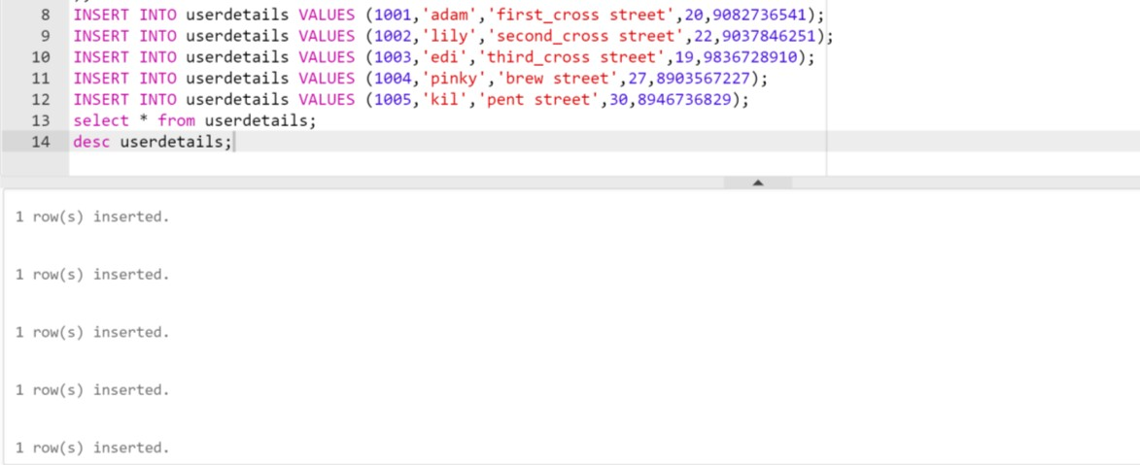

##### WEEK 3

**DCL COMMANDS**

SQL constraints are used to specify rules for data in a table. Constraints can be specified when the table is created with the CREATE TABLE statement, or after the table is created with the ALTER TABLE statement.

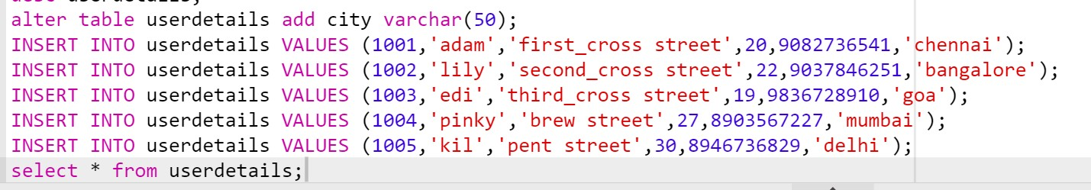

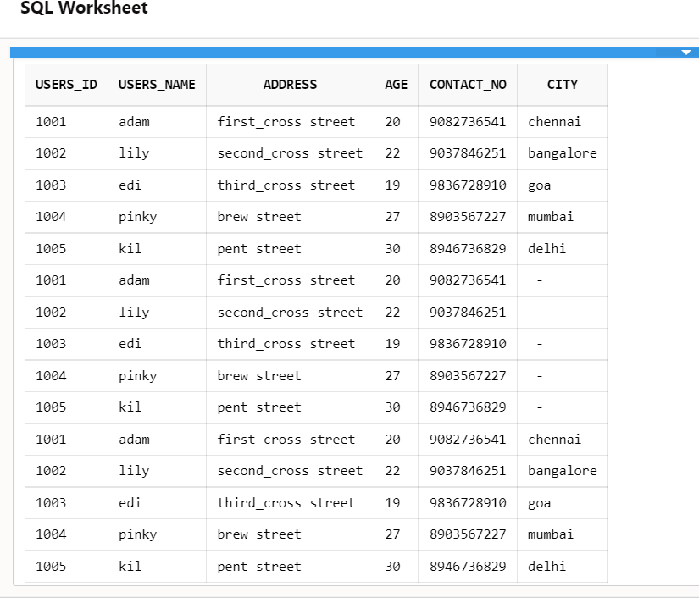

UPDATE

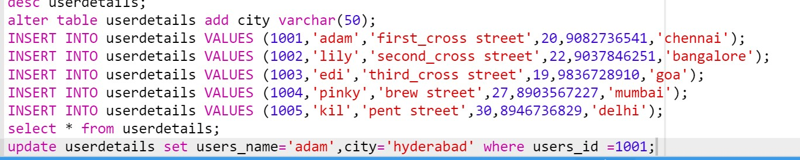

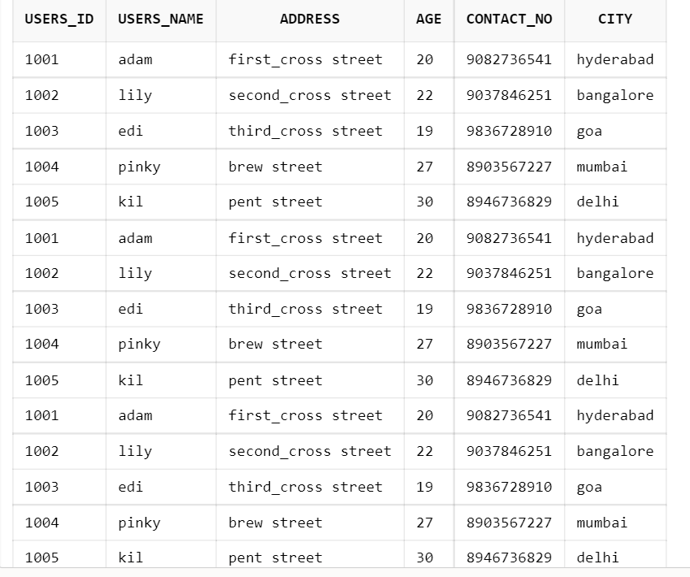

##### WEEK 4

**TCL COMMANDS**

Transaction Control Language commands are used to manage transactions in the database. These are used to manage the changes made by DML-statements. It also allows statements to be grouped together into logical transactions.

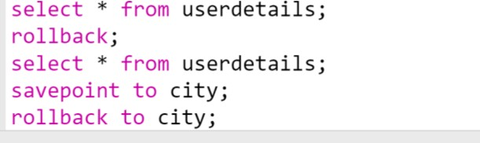

COMMIT

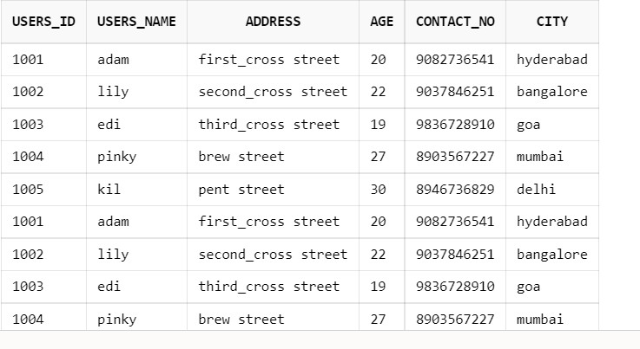

ROLLBACK

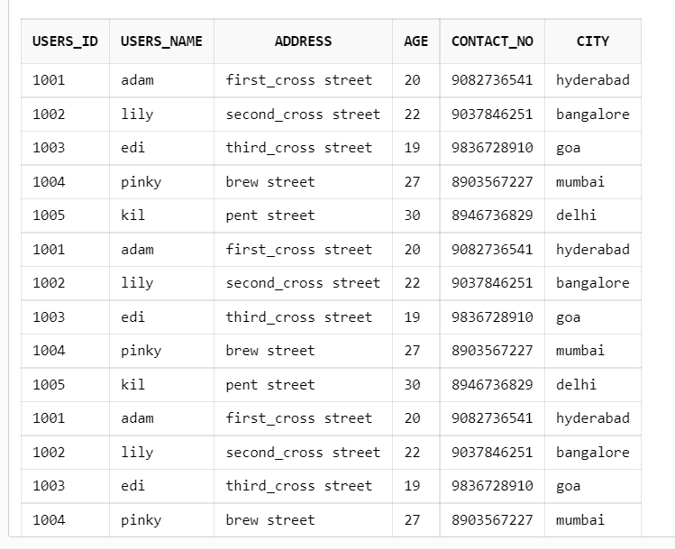

##### WEEK 5 INTEGRITY CONSTRAINTS

* Integrity constraints are a set of rules. It is used to maintain the quality of information.
* Integrity constraints ensure that the data insertion, updating, and other processes have to be performed in such a way that data integrity is not affected.
* Thus, integrity constraint is used to guard against accidental damage to the database.

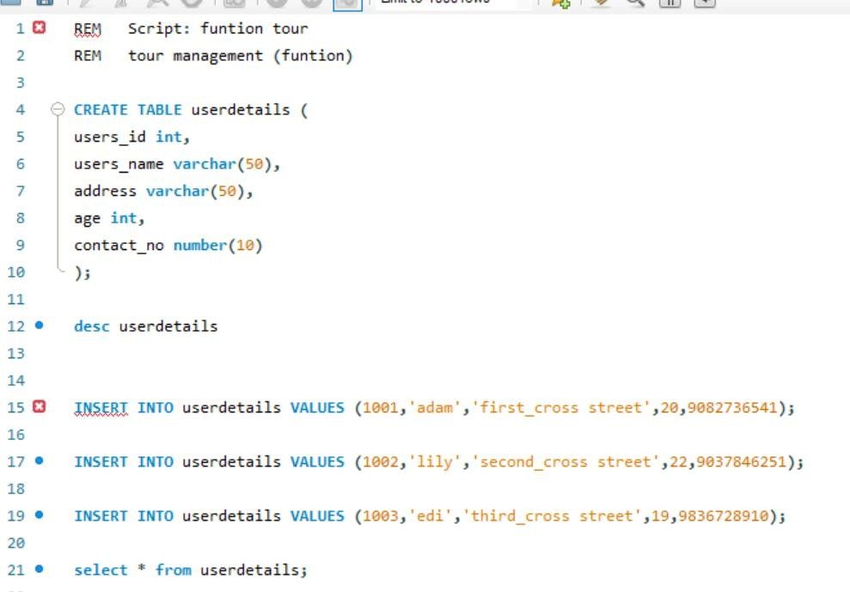

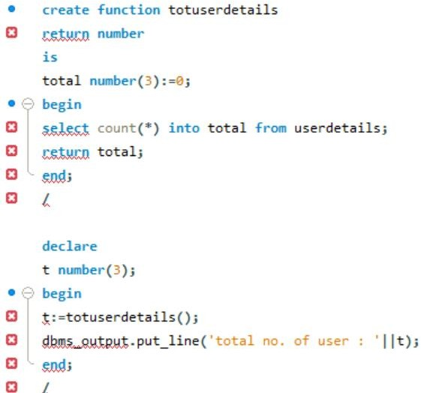

##### WEEK -6 SQL FUNCTIONS

SQL has many built-in functions for performing processing on string or numeric data. Following is the list of all useful SQL built-in functions −

* + [SQL COUNT Function](https://www.tutorialspoint.com/sql/sql-count-function.htm) - The SQL COUNT aggregate function is used to count the number of rows in a database table.
  + [SQL MAX Function](https://www.tutorialspoint.com/sql/sql-max-function.htm) - The SQL MAX aggregate function allows us to select the highest (maximum) value for a certain column.
  + [SQL MIN Function](https://www.tutorialspoint.com/sql/sql-min-function.htm) - The SQL MIN aggregate function allows us to select the lowest (minimum) value for a certain column.
  + [SQL AVG Function](https://www.tutorialspoint.com/sql/sql-avg-function.htm) - The SQL AVG aggregate function selects the average value for certain table column.
  + [SQL SUM Function](https://www.tutorialspoint.com/sql/sql-sum-function.htm) - The SQL SUM aggregate function allows selecting the total for a numeric column.
  + [SQL SQRT Functions](https://www.tutorialspoint.com/sql/sql-sqrt-function.htm) - This is used to generate a square root of a given number.
  + [SQL RAND Function](https://www.tutorialspoint.com/sql/sql-rand-function.htm) - This is used to generate a random number using SQL command.
  + [SQL CONCAT Function](https://www.tutorialspoint.com/sql/sql-concat-function.htm) - This is used to concatenate any string inside any SQL command.
  + [SQL Numeric Functions](https://www.tutorialspoint.com/sql/sql-numeric-functions.htm) - Complete list of SQL functions required to manipulate numbers in SQL.
  + [SQL String Functions](https://www.tutorialspoint.com/sql/sql-string-functions.htm) - Complete list of SQL functions required to manipulate strings in SQL.

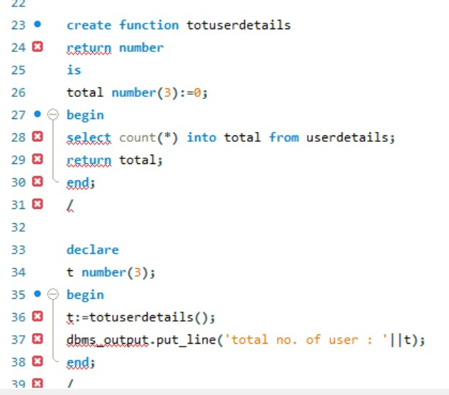

**WEEK-7 ER DIAGRAM**



**WEEK-8**

**SQL JOINING TABLES**

* (INNER) JOIN: Returns records that have matching values in both tables
* LEFT (OUTER) JOIN: Returns all records from the left table, and the matched records from the right table
* RIGHT (OUTER) JOIN: Returns all records from the right table, and the matched records from the left table
* FULL (OUTER) JOIN: Returns all records when there is a match in either left or right table

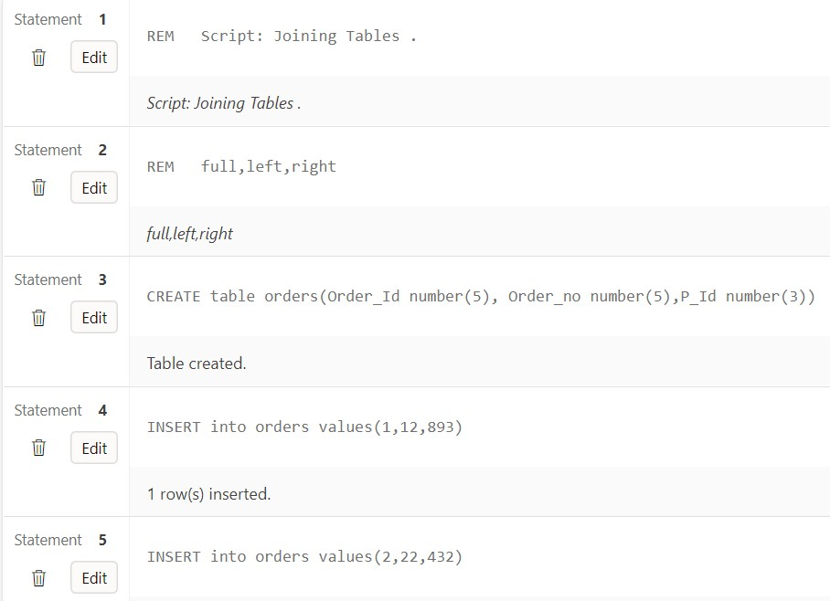

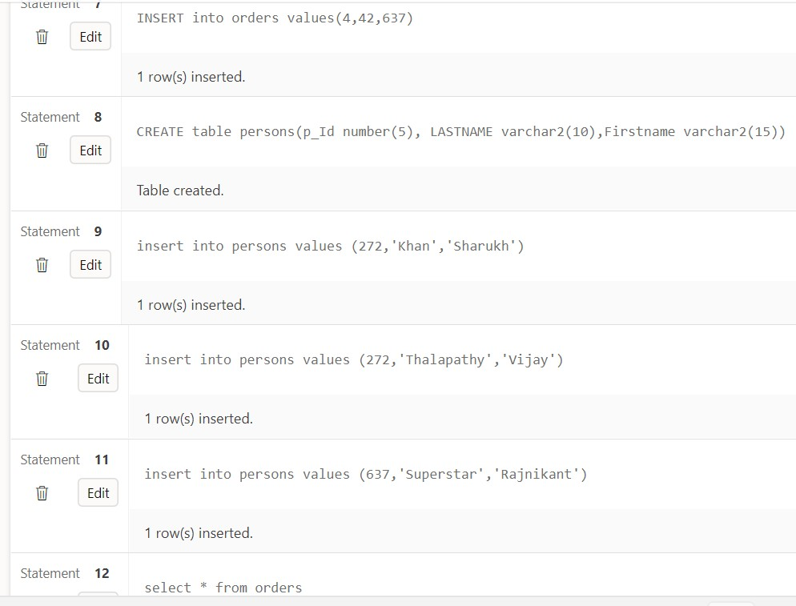

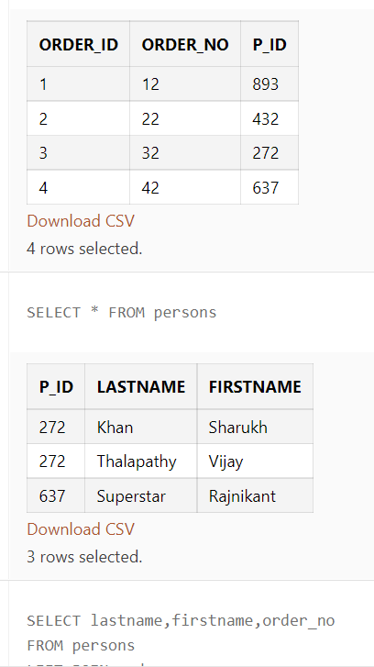 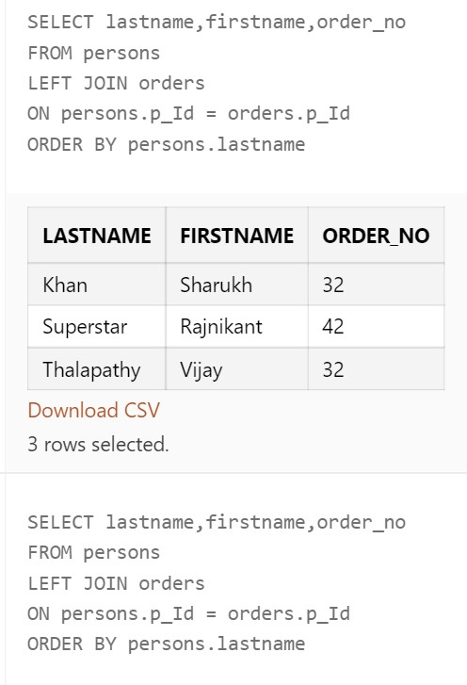

LEFT JOIN

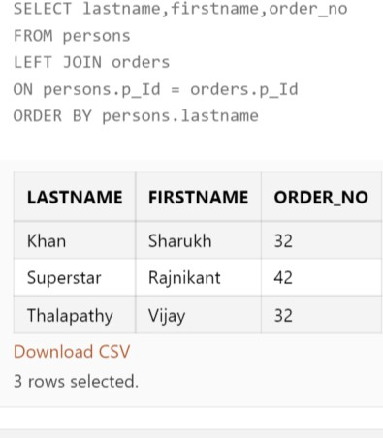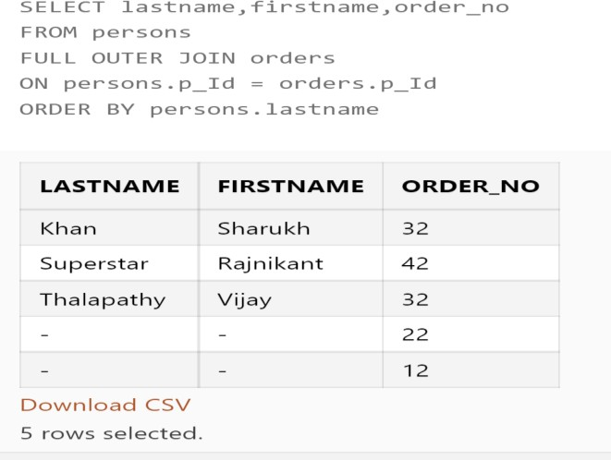

RIGHTH OUTER JOIN

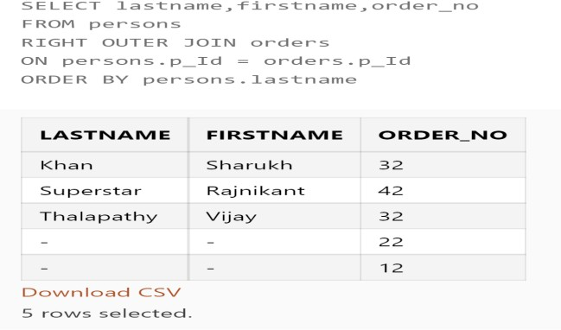

INNER JOIN

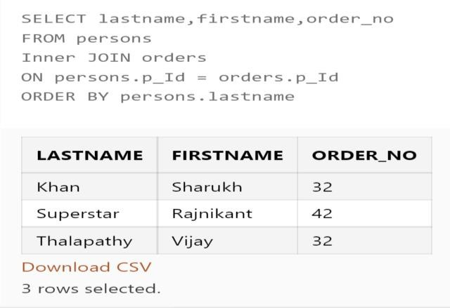

##### WEEK -9 SUB QUERIES

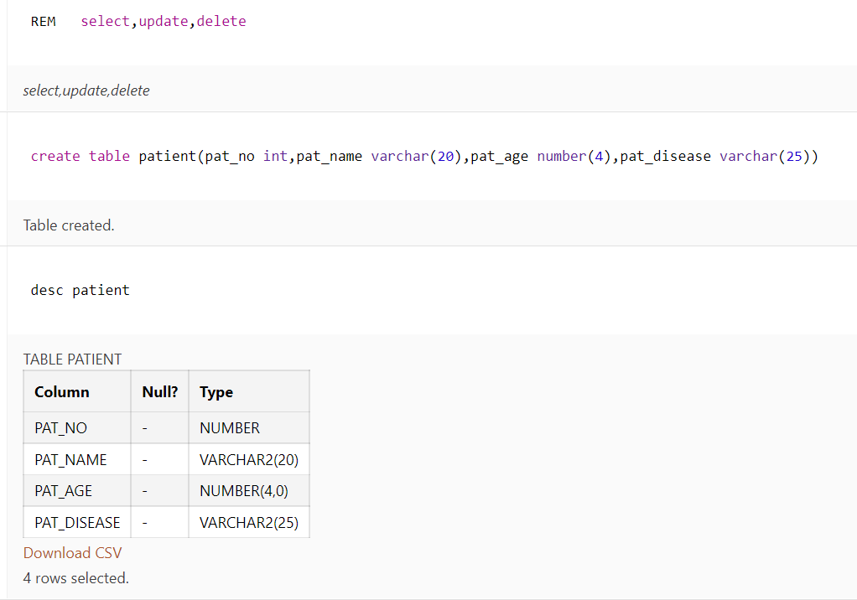

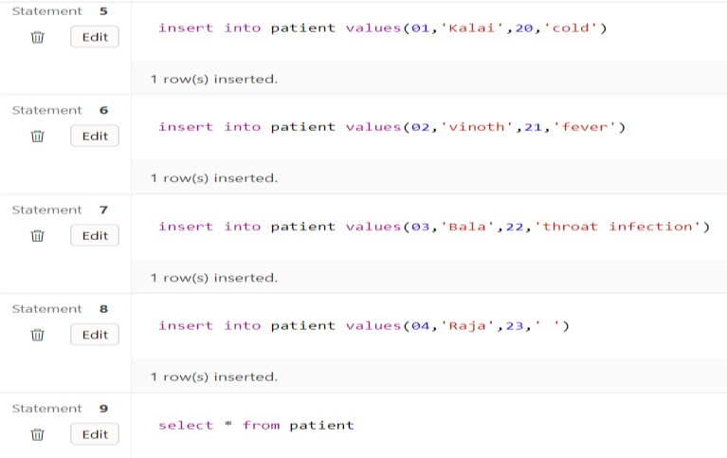

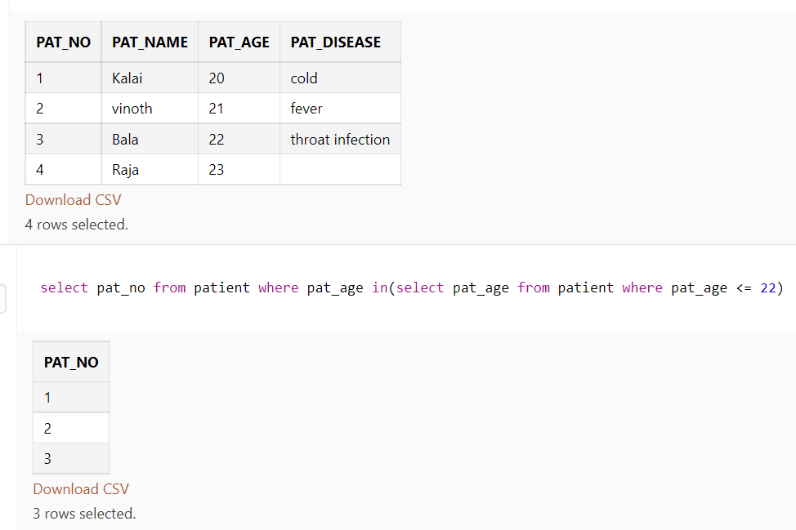

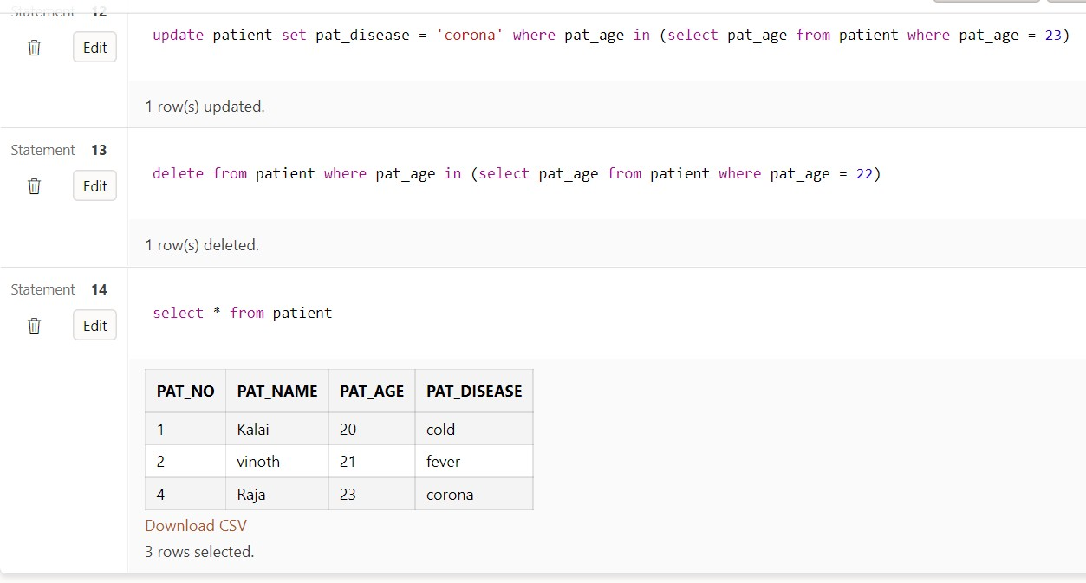

**WEEK-10 PL/SQL FUNCTIONS**

These subprograms are combined to form larger programs. This is basically called the 'Modular design'. A subprogram can be invoked by another subprogram or program which is called the **calling program**.

A subprogram can be created −

* + At the schema level
  + Inside a package
  + Inside a PL/SQL block

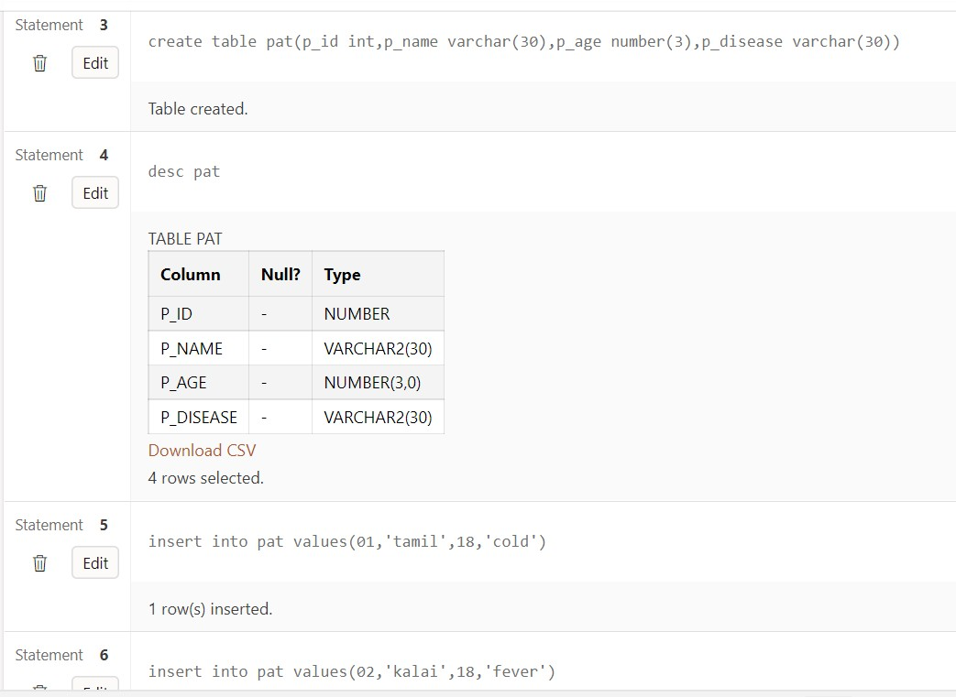

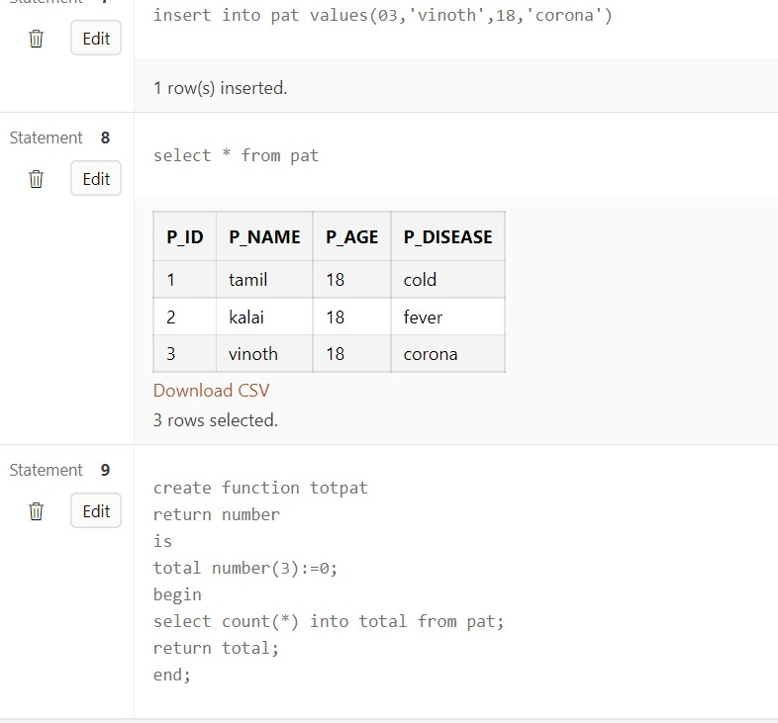

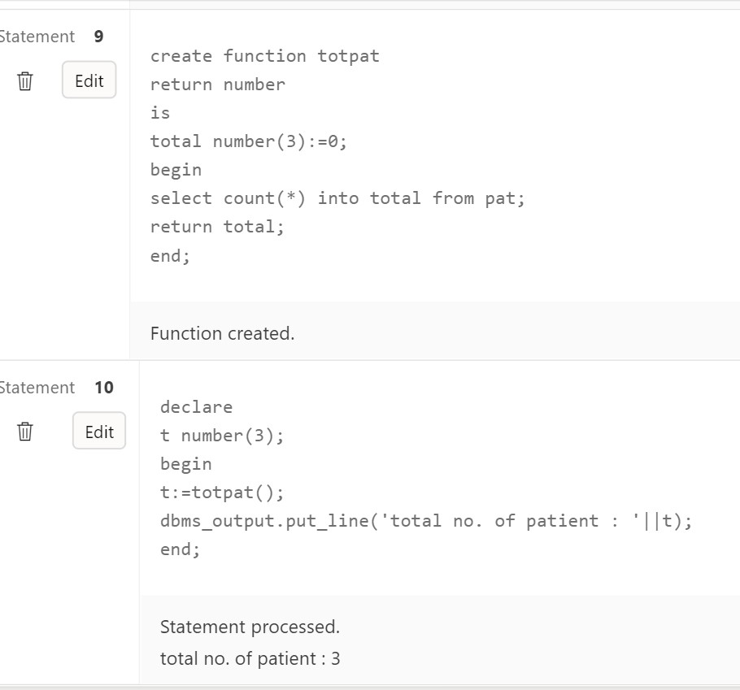

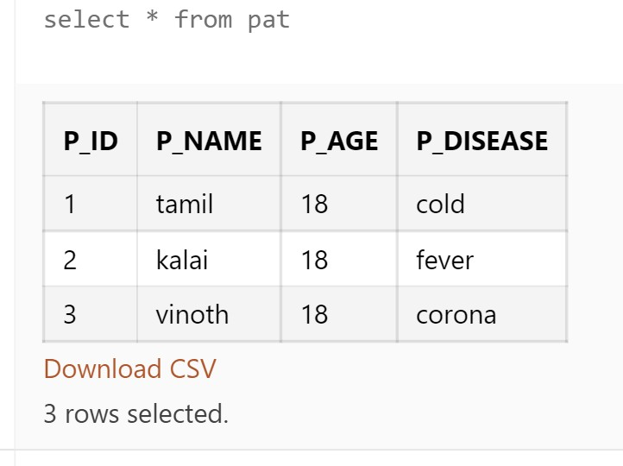

##### WEEK-11 PL/SQL TRIGGERS

* + A **database manipulation (DML)** statement (DELETE, INSERT, or UPDATE)
  + A **database definition (DDL)** statement (CREATE, ALTER, or DROP).
  + A **database operation** (SERVERERROR, LOGON, LOGOFF, STARTUP, or SHUTDOWN)
  + Triggers can be defined on the table, view, schema, or database with which the event is associated.

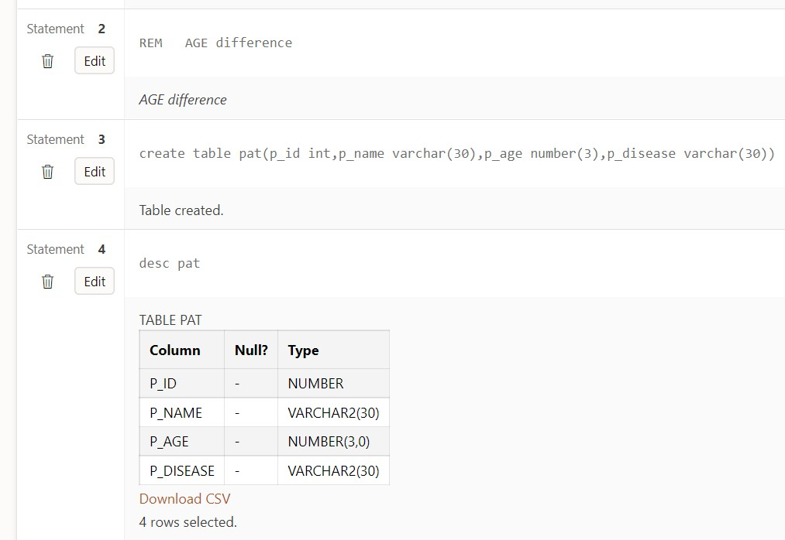

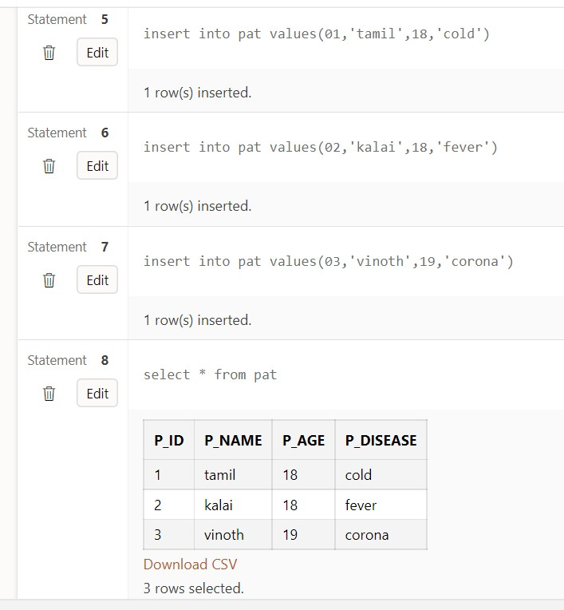

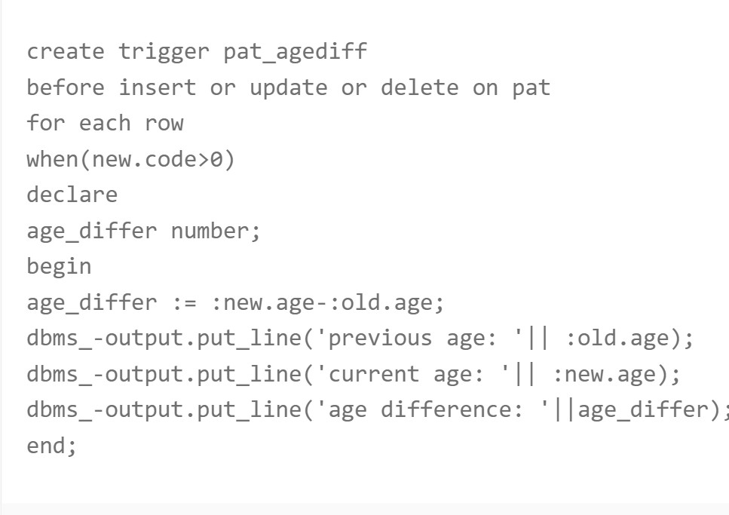

##### WEEK-12 CURSORS

A **cursor** is a pointer to this context area. PL/SQL controls the context area through a cursor. A cursor holds the rows (one or more) returned by a SQL statement. The set of rows the cursor holds is referred to as the **active set**.

You can name a cursor so that it could be referred to in a program to fetch and process the rows returned by the SQL statement, one at a time. There are two types of cursors −

* + Implicit cursors
  + Explicit cursors

Implicit Cursors

* Implicit cursors are automatically created by Oracle whenever an SQL statement is executed, when there is no explicit cursor for the statement. Programmers cannot control the implicit cursors and the information in it.

#### Explicit Cursors

* Explicit cursors are programmer-defined cursors for gaining more control over the **context area**. An explicit cursor should be defined in the declaration section of the PL/SQL Block. It is created on a SELECT Statement which returns more than one row.

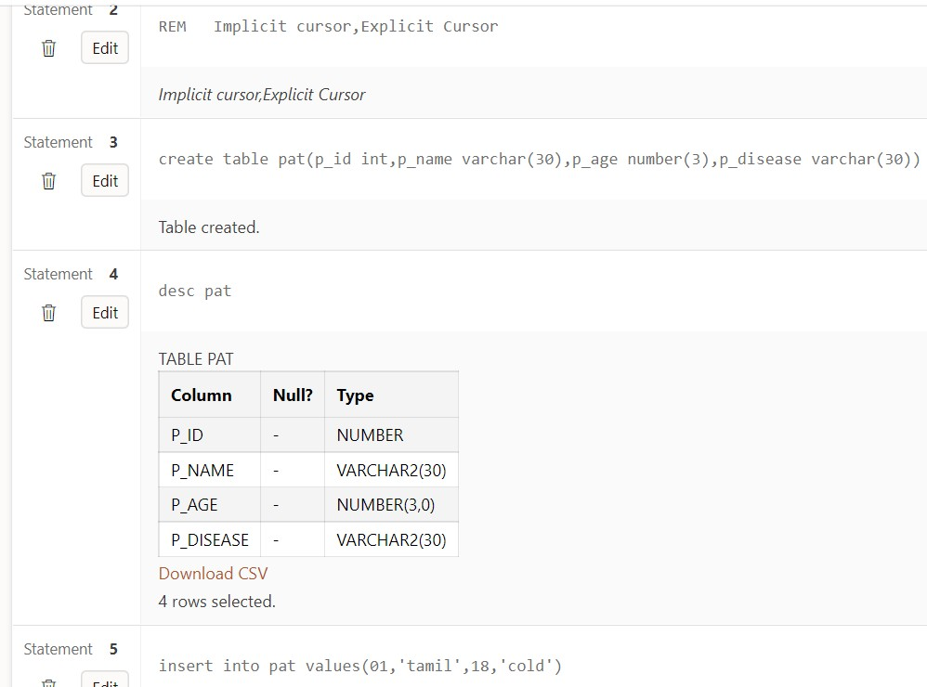

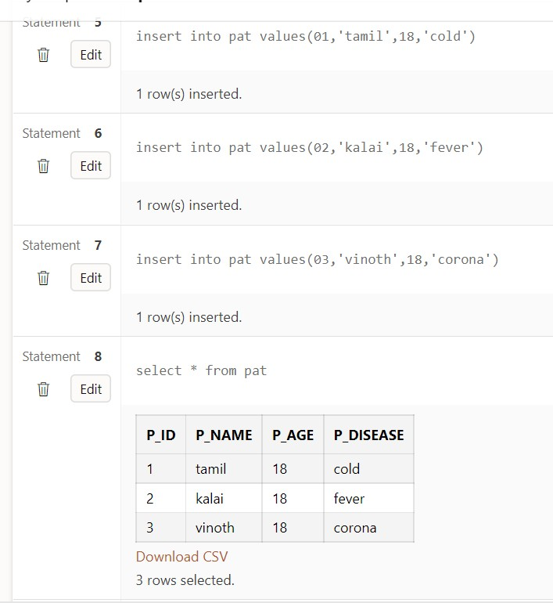

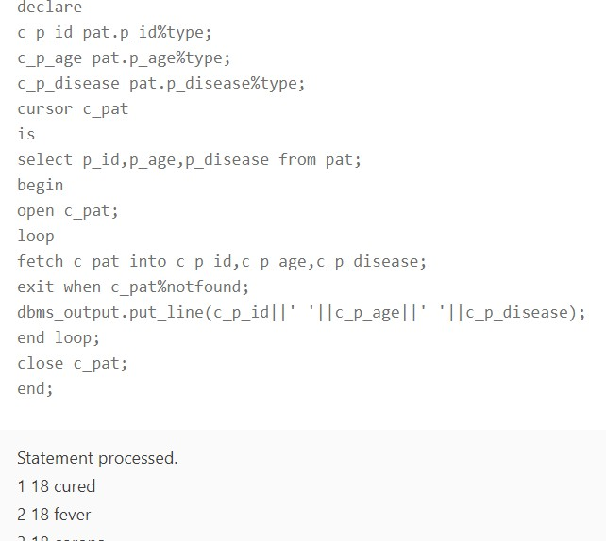

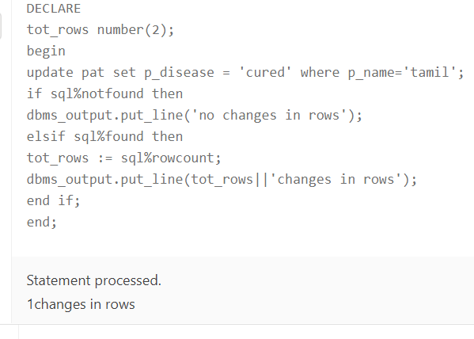

##### WEEK -13 EXCEPTION HANDLING

An error condition during a program execution is called an exception and the mechanism for resolving such an exception is known as exception handling. In this article, we will learn how to implement exception handling in SQL Server. SQL Server provides TRY, CATCH blocks for exception handling. We can put all T-SQL statements into a TRY BLOCK and the code for exception handling can be put into a CATCH block. We can also generate user-defined errors using a THROW block.

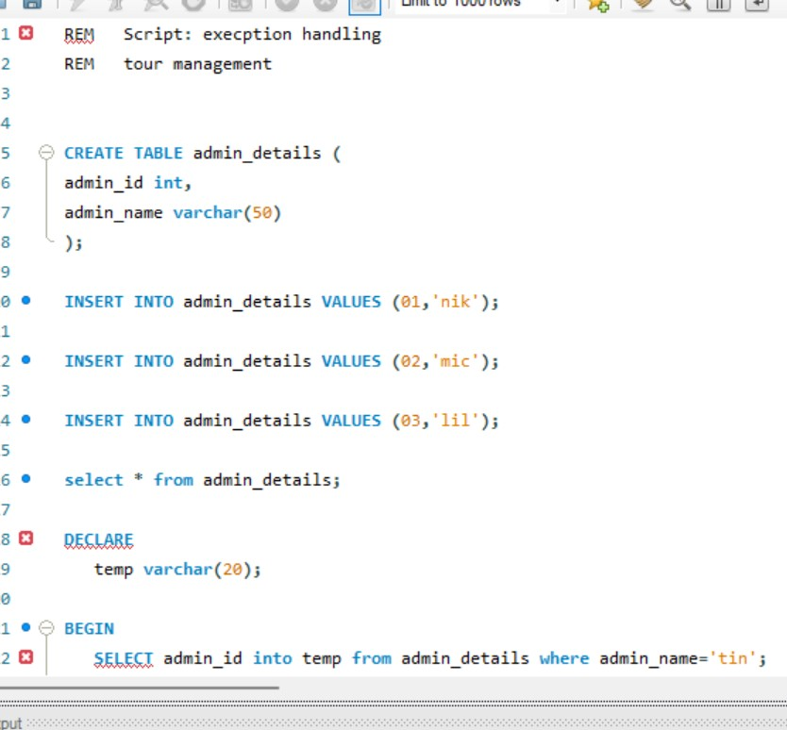

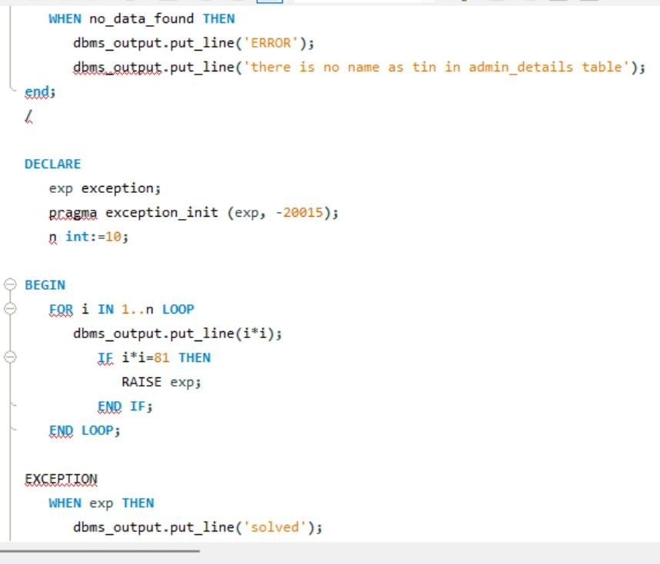

##### Week-14

**SET OPERATORS AND VIEWS**

1. mysql> **SELECT** \***FROM** t_students **UNION SELECT** \***FROM** t2_students;
2. mysql> **SELECT** \***FROM** t_employees **UNION** ALL **SELECT** \***FROM** t2_employe es;
3. mysql> **SELECT** \***FROM** t_students **UNION** ALL **SELECT** \***FROM** t2_students;
4. mysql> **SELECT** \***FROM** t_employees **INTERSECT SELECT** \***FROM** t2_employe es;
5. mysql> **SELECT** \***FROM** t_employees MINUS **SELECT** \***FROM** t2_employees;
6. mysql> **SELECT** \***FROM** t_students MINUS **SELECT** \***FROM** t2_students;

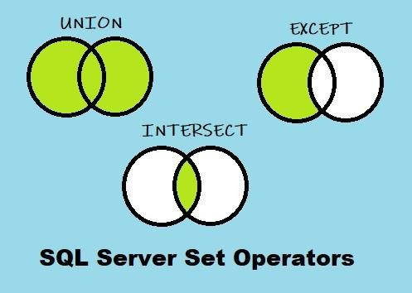

##### References:

<https://www.w3schools.com/sql/sql_unique.asp>

<https://www.w3schools.com/sql/sql_join.asp> <https://www.tutorialspoint.com/plsql/index.htm>

https://[www.tutorialspoint.com/plsql/plsql_exceptions.h](http://www.tutorialspoint.com/plsql/plsql_exceptions.h) tm https://[www.geeksforgeeks.org/sql-ddl-dql-dml-dcl-tclcommands/](http://www.geeksforgeeks.org/sql-ddl-dql-dml-dcl-tclcommands/)

https://[www.geeksforgeeks.org/sql-trigger-studentdatabase/](http://www.geeksforgeeks.org/sql-trigger-studentdatabase/)

https://[www.w3schools.com/sql/sql_view.asp](http://www.w3schools.com/sql/sql_view.asp) https://docs.microsoft.com/en- us/sql/sqlserver/?view=sql-server-ver1